**Executive Secretary Course**

**Basic English**

**Teacher Laury Antigua**

**Vocabulary**

**Learn the vocabulary**

|  |  |  |
| --- | --- | --- |
| **Country** | **Nationality** | **Language** |
| Argentina | Argentine | Spanish |
| Australia | Australian | English |
| Brazil | Brazilian | Portuguese |
| China | Chinese | Chinese |
| The Dominican Republic | Dominican | Spanish |
| Egypt | Egyptian | Arabic |
| England | English | English |
| France | French | French |
| Germany | German | German |
| Haiti | Haitian | French / Creole |
| Italy | Italian | Italian |
| Japan | Japanese | Japanese |
| Mexico | Mexican | Spanish |
| Russia | Russian | Russian |
| Spain | Spanish | Spanish |
| The UK) United Kingdom | British | English |

|  |  |  |
| --- | --- | --- |
| (The US) United States | American | English |
| Colombia | Colombian | Spanish |
| Puerto Rico | Puerto Rican | Spanish |
| Vietnam | Vietnamese | Vietnamise |

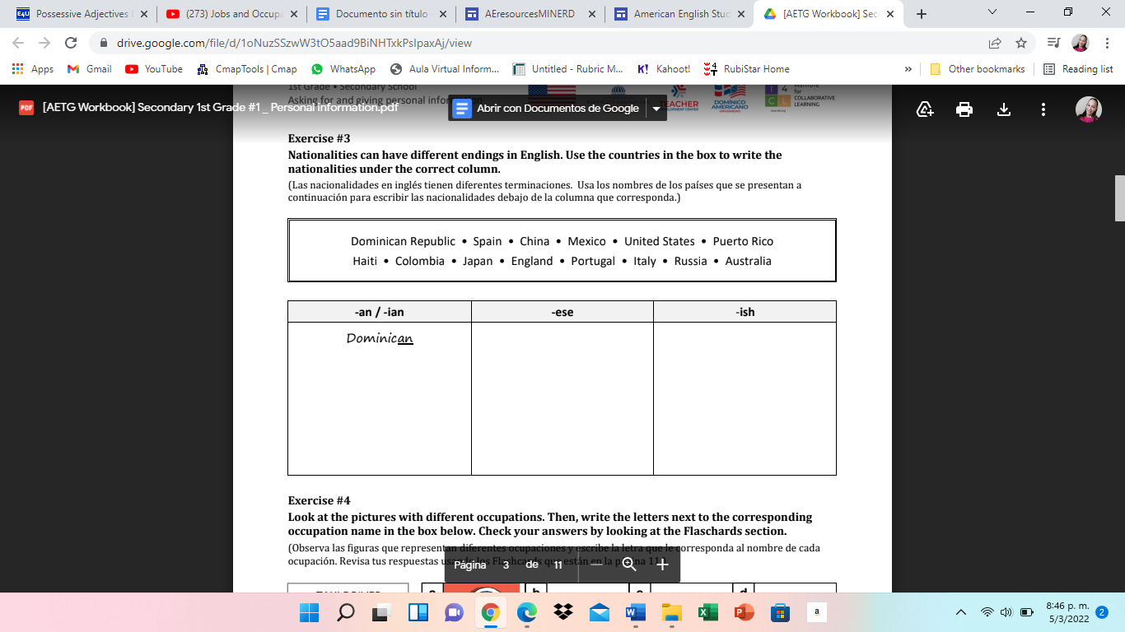

|  |  |  |
| --- | --- | --- |
| **-an/-ian** | **-ese** | **-ish** |
|  |  |  |

**Complete the sentences with the forms of to be in the present simple (am, is, are). Completar utilizando el verbo to be.**

1. I __am_____ student.
2. She ___are______ italian.
3. We ___are_____ Americans.
4. You __is_______ spanish.
5. They _are_______ in the park.
6. He ____is____ mexican.
7. I ____am_____ british.
8. Mary ___is___ an engineer.
9. Carlos _is____ a good friend.
10. Ashley and you __am____ partners.

**Complete using your own information:** (completar con tu información)

Name: Wilmary

Last name: Sánchez Marcelino

City: Dominicana

Country: San Francisco

Job: Amada de casa

Age:19

**Write 5 Jobs.** (escribir 5 ocupaciones)